**Assignment 1 - 10%**

**Part 1: Individual Task**

**CO coverage: CO2 & CO4**

**Due Date: 2 weeks (Part 1) - Week 7**

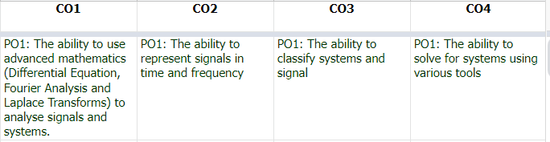

1. Use available resources to record speech under three different condition: (CO2)

* Normal environment
* Quiet environment
* Noisy environment

File type: WAV file

2. Record speech in BM (CO4)

* Satu
* Dua
* Tiga
* Empat
* Lima
* Enam
* Tujuh
* Lapan
* Sembilan
* Sepuluh

3. Record speech in English (CO4)

* One
* Two
* Three
* Four
* Five
* Six
* Seven
* Eight
* Nine
* Ten

4. Save each audio with consistent file name (CO2)

SatuNinitial

SatuQinitial

SatuWinitial

Eg: name- [ROSALYN R PORLE -](mailto:rlyn39@ums.edu.my)my initial = rrp

SatuNrrp

SatuQrrp

SatuWrrp

Total wave file = 10 BM x 3 E + 10 BI x 3 = 60 wave files

5. Describe in detail how you perform task 1 (CO4)

* Hardware (mic/no mic, devices) - how far you with devices (distance)
* Software - not necessarily Octave and MATLAB
* Online resources that you use - references
* Environment
  + Normal - at room in KK, with ceiling fan on
  + Quiet -
  + Noisy

6. Display the audio in graphical/diagram in A4 landscape for each language. (CO2)

7. Compare the document in 6 by observation technique. (CO2)